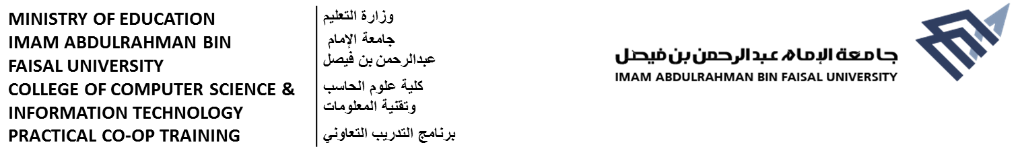
BIWEEKLY PROGRESS REPORT – WEEKs 3-4 (PCT 104)
Student Information
Student Name | Abdulrahman Saleh Alaamri |  | ID Number | 2240002427
Company Name | Saudi Aramco
Submission Date | 23/07/2026 | Marks Obtained

Progress Report Information: Brief description of activities, assignments, projects and type of training you were involved during each week of training, and problems faced with the resources used (Individuals, Books, and websites).
Tasks Done (10 marks) |  | Challenges Faced (2.5 marks) | Resources Used (2.5 marks)
- One of my team's tools translates a patent into Arabic from a formatted Word file. I built a Python tool where the user enters only a patent number (e.g. US20250097171A1); it retrieves the patent from Google Patents and give it to the tool as JSON.  - Investigated with the team why part of the tool’s Arabic output gets cut off, likely a token-limit issue. Not solved yet.  - Wrote a Python script comparing several models Arabic translation via OpenRouter. Not finish yet.  - Built a design for automation that reads Outlook emails, uses AI to extract meetings, deadlines, tasks, and priority, then creates Calendar events and Microsoft To Do tasks.  - set up a Windows VM with UiPath Studio, and started building with REFramework.  - Director meeting on the department's vision.  - Online sessions on RPA and AI in cybersecurity. |  | The biggest challenge was the development environment. UiPath does not run on Mac, so I first tried Microsoft Power Automate. It worked until I needed the AI and HTTP actions, which require a Premium license that the university account does not have, and I could not use a personal account for it. I solved this by setting up a Windows virtual machine and moving the project back to UiPath, reusing the design and logic I had already built. The other two challenges are still open: the missing tokens problem in the Arabic translation is not solved yet, and my model comparison results are not clear enough to make a recommendation. | - UiPath Studio  - Microsoft Power Automate and SharePoint  - Windows virtual machine (UTM)  - Python with OpenRouter, for the model comparison  - The Gemini API, for the AI extraction step  - Google Patents, as the patent data source  - Microsoft 365 (Outlook, Microsoft To Do)  - Guidance from my supervisor and the legal solutions team  - Aramco’s internal onboarding/compliance training platform (Success Factor)
*Student MUST send this report to his/her Academic Supervisor

